1. Realiza las siguientes operaciones lógicas (bit a bit):
   1. NOT 11010001

|  |  |  |  |  |  |  |  |
| --- | --- | --- | --- | --- | --- | --- | --- |
| 1 | 1 | 0 | 1 | 0 | 0 | 0 | 1 |
| 0 | 0 | 1 | 0 | 1 | 1 | 1 | 0 |

* 1. 11000101 AND 11010101

|  |  |  |  |  |  |  |  |
| --- | --- | --- | --- | --- | --- | --- | --- |
| 1 | 1 | 0 | 0 | 0 | 1 | 0 | 1 |
| 1 | 1 | 0 | 1 | 0 | 1 | 0 | 1 |
| 1 | 1 | 0 | 0 | 0 | 1 | 0 | 1 |

* 1. 10101011 AND 11100111

|  |  |  |  |  |  |  |  |
| --- | --- | --- | --- | --- | --- | --- | --- |
| 1 | 0 | 1 | 0 | 1 | 0 | 1 | 1 |
| 1 | 1 | 1 | 0 | 0 | 1 | 1 | 1 |
| 1 | 0 | 1 | 0 | 0 | 0 | 1 | 1 |

* 1. 10011010 AND 11001101

|  |  |  |  |  |  |  |  |
| --- | --- | --- | --- | --- | --- | --- | --- |
| 1 | 0 | 0 | 1 | 1 | 0 | 1 | 0 |
| 1 | 1 | 0 | 0 | 1 | 1 | 0 | 1 |
| 1 | 0 | 0 | 0 | 1 | 0 | 0 | 0 |

* 1. 11010001 OR 11101101

|  |  |  |  |  |  |  |  |
| --- | --- | --- | --- | --- | --- | --- | --- |
| 1 | 1 | 0 | 1 | 0 | 0 | 0 | 1 |
| 1 | 1 | 1 | 0 | 1 | 1 | 0 | 1 |
| 1 | 1 | 1 | 1 | 1 | 1 | 0 | 1 |

* 1. 10101001 OR 11001100

|  |  |  |  |  |  |  |  |
| --- | --- | --- | --- | --- | --- | --- | --- |
| 1 | 0 | 1 | 0 | 1 | 0 | 0 | 1 |
| 1 | 1 | 0 | 0 | 1 | 1 | 0 | 0 |
| 1 | 1 | 1 | 0 | 1 | 1 | 0 | 1 |

* 1. 00111011 OR 10100111

|  |  |  |  |  |  |  |  |
| --- | --- | --- | --- | --- | --- | --- | --- |
| 0 | 0 | 1 | 1 | 1 | 0 | 1 | 1 |
| 1 | 0 | 1 | 0 | 0 | 1 | 1 | 1 |
| 1 | 0 | 1 | 1 | 1 | 1 | 1 | 1 |

1. Realiza la tabla de verdad de la siguiente función lógica: F = A·B+Ā·C

|  |  |  |  |
| --- | --- | --- | --- |
| A | B | C | F = A·B+Ā·C |
| 0 | 0 | 0 | 0 |
| 0 | 0 | 1 | 1 |
| 0 | 1 | 0 | 0 |
| 0 | 1 | 1 | 1 |
| 1 | 0 | 0 | 0 |
| 1 | 0 | 1 | 0 |
| 1 | 1 | 0 | 1 |
| 1 | 1 | 1 | 1 |

1. Implementa en la aplicación Logicly el circuito lógico correspondiente a la anterior función y comprueba si la tabla de verdad es correcta.

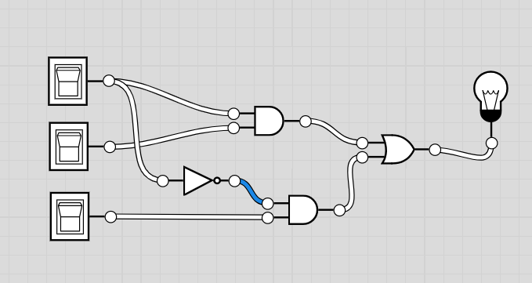

1. Codifica la siguiente cadena de caracteres en ISO-8859-1 (Latin 1). En hexadecimal la cadena completa y en binario sólo hasta los “:”.

Correo: usuario@dominio.es

HEXADECIMAL:

|  |  |  |  |  |  |  |  |  |  |
| --- | --- | --- | --- | --- | --- | --- | --- | --- | --- |
| C | o | r | r | e | o | : |  | u | s |
| 43 | 6F | 72 | 72 | 65 | 6F | 3A | A0 | 75 | 73 |

|  |  |  |  |  |  |  |  |  |  |  |  |  |  |  |  |
| --- | --- | --- | --- | --- | --- | --- | --- | --- | --- | --- | --- | --- | --- | --- | --- |
| u | a | r | i | o | @ | d | o | m | i | n | i | o | . | e | s |
| 75 | 61 | 72 | 69 | 6F | 40 | 64 | 6F | 6D | 69 | 6E | 69 | 6F | 2E | 65 | 73 |

BINARIO:

|  |  |  |  |
| --- | --- | --- | --- |
| C | o | r | r |
| 01000011 | 01101111 | 01110010 | 01110010 |

|  |  |  |
| --- | --- | --- |
| e | o | : |
| 01100101 | 01101111 | 00111010 |

1. El estándar actual que permite codificar cualquier idioma al medio informático se llama:
   1. ASCII
   2. ISO-8859-1 (Latin 1)
   3. UNICODE
2. Transforma los siguientes datos en bits:
   1. 3 Kibits -3072
   2. 3 KiB - 24576
   3. 3 GiB -2,5^10
3. Si se tiene un disco duro de 900 GiB, ¿cuántos Gibits almacena? ¿y cuántos MiB?

Almacena 7200 Gibits y 921600 MiB

1. ¿Cuántos GiB son 1 TiB? Son 931 GiB
2. ¿Cuántos GB son 1 TB? Son 1000 GB
3. ¿Cuántos GiB son 1 PiB? Son 1⁶GiB
4. ¿Cuántos GB son 1 PB? Son 1⁶ GB